**User Case Diagram**

Use Case Diagrams emphasize the actors' and qualities' relationships and networks. The linkages and priorities can be grafted into a visually appealing display**.**

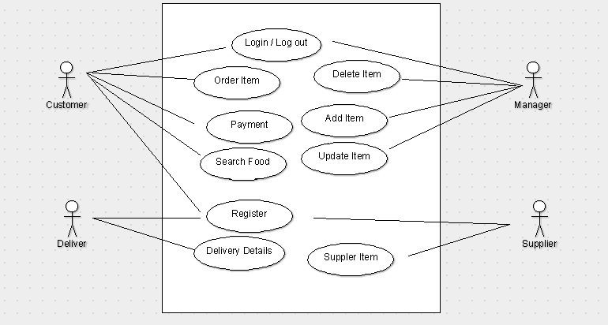

**Activity Diagram**

The activity diagram in UML, also known as a behavioral diagram, is a graphical depiction of a group of conducted processes that depicts parallel and conditional activities, use cases, and functions. This diagram depicts the system's control flow**.**

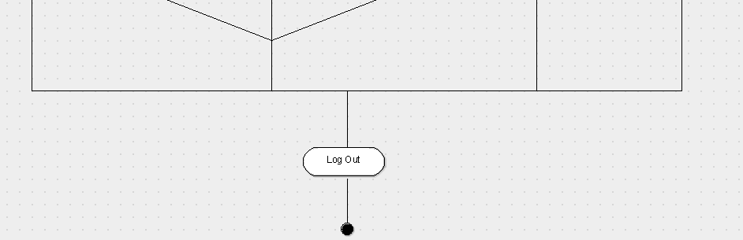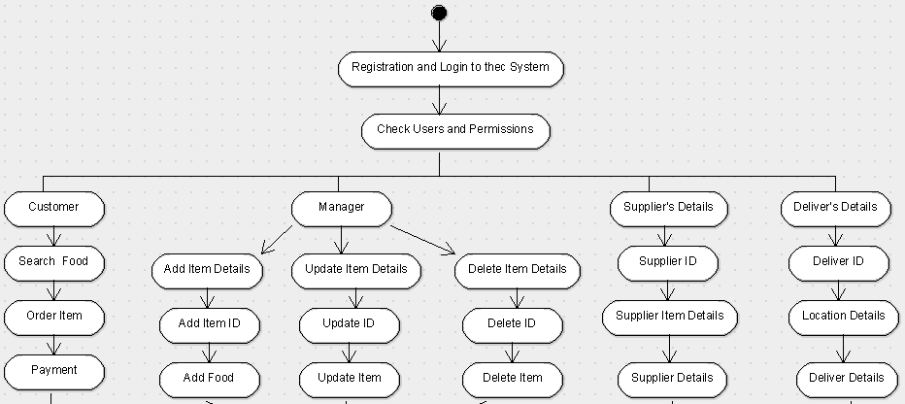

**State machine Diagram**

The state machine diagram, also known as the state chart diagram, is a behavioral diagram in UML that displays transitions between distinct objects. It is often used to represent state dependent behavior of an item.



**Class Diagram**

In UML, a Class Diagram is a form of Static Structure Diagram that depicts the system's structure. This is referred to as the leading block in Object Oriented Modelling (OOM).

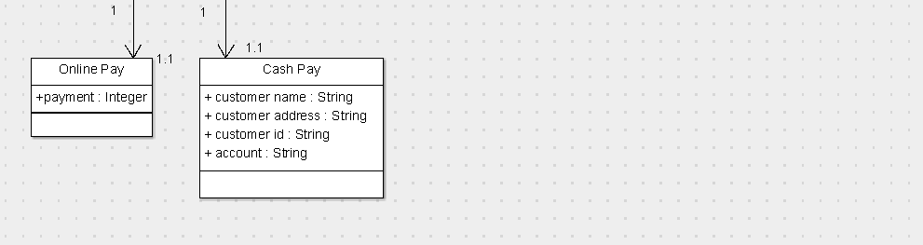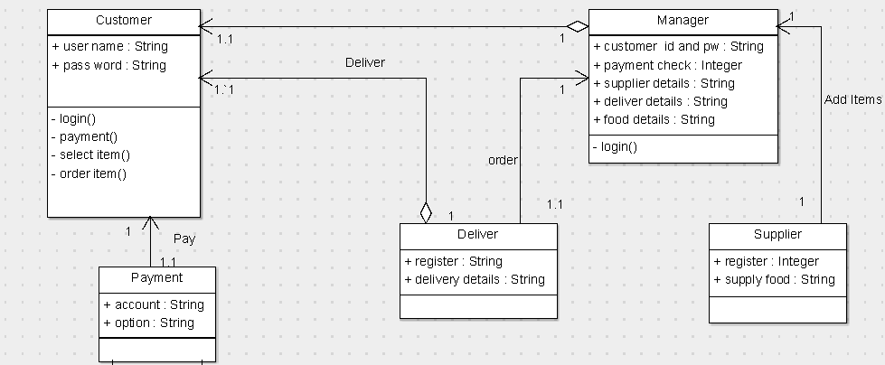

**Code Generation with Argo UML Screenshots as Evidence**

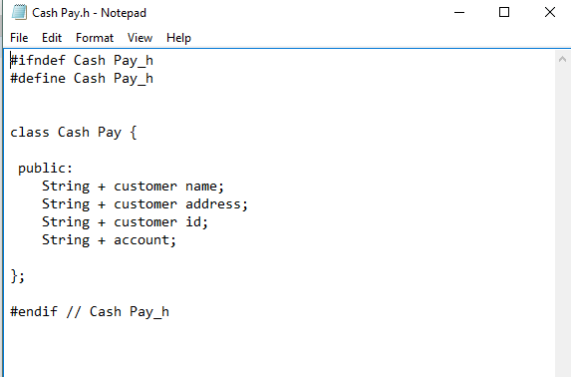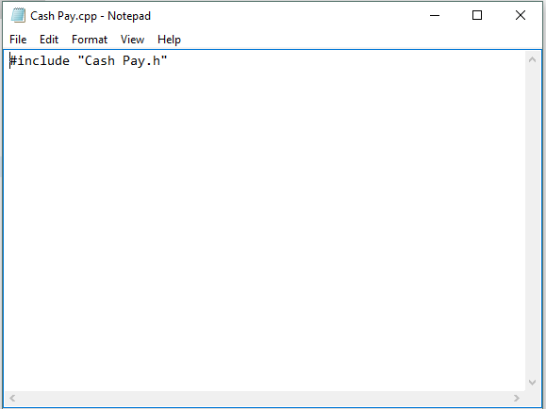

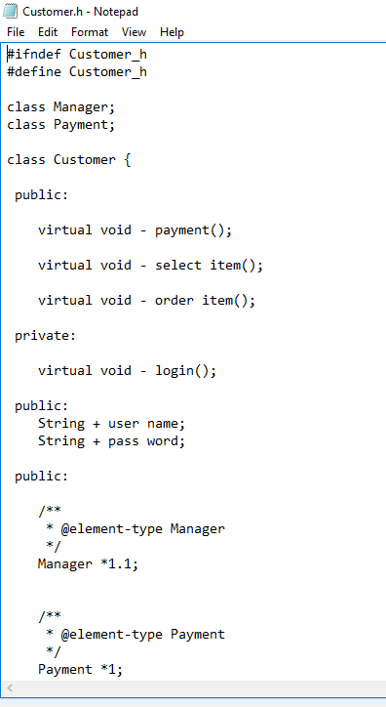

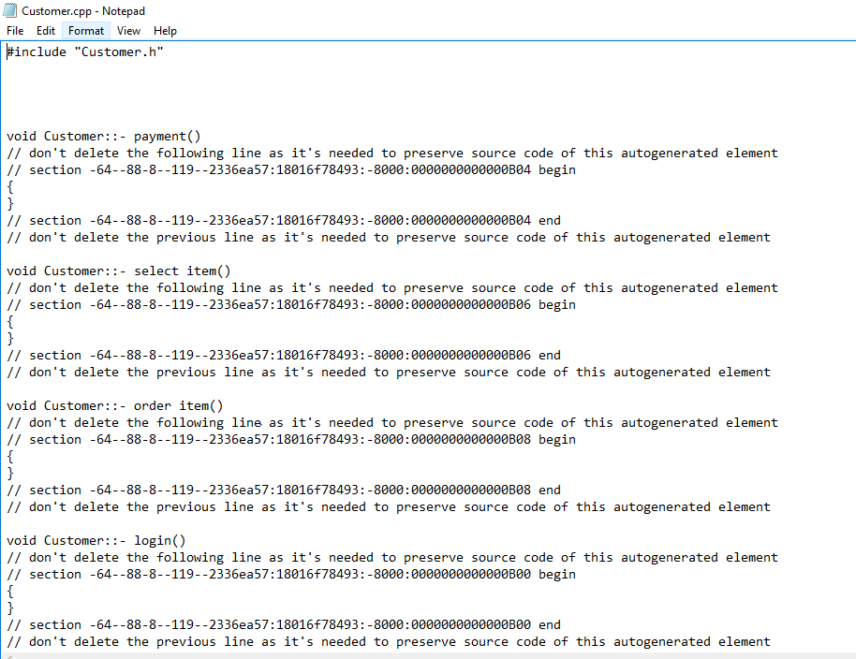

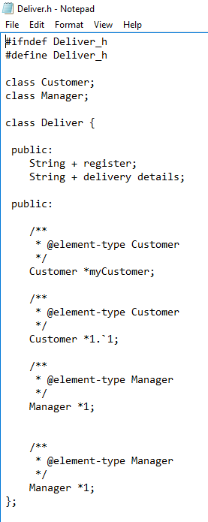

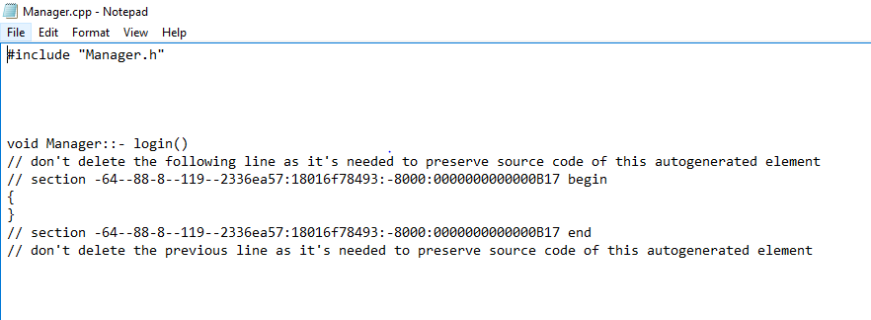

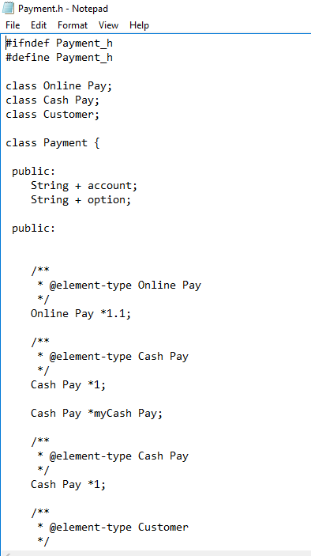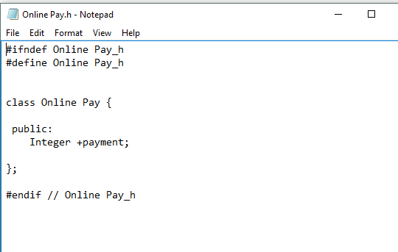

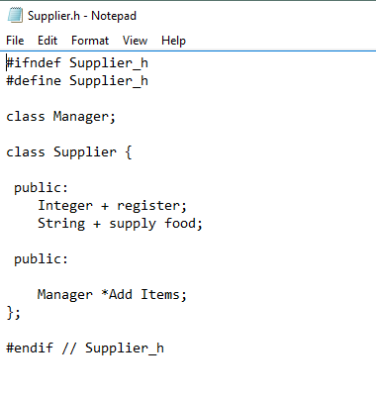

**Collaboration Diagram**

**System**:



**Workflow of the proposed system**

**Login:**

1. The actors (Customer/ Manager) should be able to logon in a way that is meaningful to them.

• Employees should log in using their legitimate credentials.

• Customer– register for free online.

1. The system enables the Super Admin to create new accounts for newly hired workers responsible for ushering guests and management.
2. The system would allow logged-in employees to change their passwords at their leisure.
3. Users would be able to log out at any time.

**Ordering**:

5. Customer can view menu they want to order according to category.

6. Customer can view selected order description.

7. The system would allow customer to get registered at the time of order.

8. System will update new food item based on check – ins and check – outs.

9. System allows customer to view the order they have made.

10. Manager and distributor would be able to see order made as of new.

11. Customer can update their registration if needed.

12. System will provide a payment option (offline/online).

13. System sends confirmation email at time of ordering.

**Reports generated:**

1. System Checks each order book under all categories and generates reports
2. System generates a daily income and monthly report at specified time according to the number of order food item.